

**Coral Glades High School  
AICE Planning Sheet- Course Progression**

**(Starting Cambridge in 9th grade with program completion in 11th grade.)**

**Student Name___________________________________ Student Number _______________**

**Graduation. Year ______________**

**H.S. Credit Earned in middle school ____ Courses: _________________________________**

The Courses in **bold** are required, and they are the minimum requirements. You should take additional courses to exceed the AICE diploma requirement.

|  |  |  |  |
| --- | --- | --- | --- |
|  | English- **AICE English General Paper** |  | English- **AICE English Language** |
|  | Social Studies- AP Human Geography or AICE Geography |  | Social Studies- **AICE European History** |
|  | Math- |  | Math- |
|  | Science- |  | Science- |
|  | **Elective- Thinking Skills** (If you are enrolled in geometry or higher) |  | **Elective- at least one additional AICE course** |
|  | Elective- |  | Elective- |
|  | Elective- |  | Elective- |

First Year Schedule: Second Year Schedule:

Third Year Schedule: Fourth Year Schedule:

|  |  |  |  |
| --- | --- | --- | --- |
|  | English- |  | English- |
|  | Social Studies- **AICE U.S. History** |  | Social Studies- U.S. Government & Economics |
|  | Math- |  | Math- |
|  | Science- |  | Science- |
|  | **AICE Global Perspectives**  **(Compulsory)** |  | Elective- |
|  | **Elective- at least one additional AICE course** |  | Elective- |
|  | Elective- |  | Elective- |

**AICE Diploma Requirements**

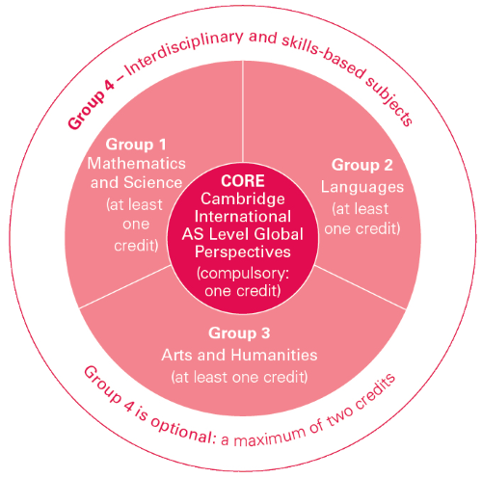To earn the Cambridge AICE Diploma, learners must achieve a minimum of **seven credits** (including Cambridge International AS Level Global Perspectives & Research) from subject groups 1, 2, and 3 (and optionally Group 4) **within a 25-month period*.** At least one credit must come from each of Groups 1, 2 and 3. The remaining credits can come from any of the groups. A maximum of two credits can count from Group 4. A Cambridge International AS Level is awarded one credit, and a Cambridge International A Level is awarded two credits.

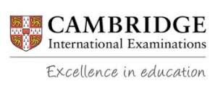

**Coral Glades Cambridge Program Offerings**

**Group 1  
Mathematics and Sciences**

___Marine Science

___Environmental Science

(1 or 3)  
  
___Psychology (1 or 3)

___Physical Education

**Group 3  
Arts and Humanities**

___U.S. Geography

___ European History

___U.S. History

___Psychology (1 or 3)

___Environmental Science (1 or 3)

___Media Studies AS

___Media Studies A

___Business

**Group 4  
Interdisciplinary and Skills-based**

**(Optional)**

_____ General Paper

_____ Thinking Skills

_____Global Perspectives A level

**Group 2  
Languages**

_____ English Language

_____ Spanish Language

**Compulsory**

___Global Perspectives AS level

AICE Psychology can count for either Group 1 or Group 3 towards the AICE diploma, and it is considered an academic elective to colleges. However, it counts as an **elective** credit on the high school transcript- not a math or science credit.

**\* within a 25-month period-** a student who starts the program as a freshman, has until the end of junior year to complete the requirements, and a student who starts the program as a sophomore, has until the end of senior year to complete the requirements.